|  |  |  |  |  |  |
| --- | --- | --- | --- | --- | --- |
|  | **GOVT POLYTECHNIC COLLEGE** | | | | |
|  | **PUNALUR** | | | | |
|  | Phone: 0475 - 2228683 | | | | |
|  | email: gptcplr@gmail.com | | | | |
|  |  | | |  |  |
|  | **Mandatory Disclosure 2020-21** | | | | |
|  | Mandatory Disclosure updated on | : | 20th feb 2020 | | |
| 1 | AICTE File No. |  | South-West/1-3514833684/2018/10-04-2018 | | |
|  | Date & Period of last approval |  | Date: 29-April-2020, Academic Year 2020-21 | | |
| 2 | Name of the Institution |  | Govt Polytechnic College, Punalur,  Permanent Institute ID:**1-500008781** | | |
|  | Address of the Institution |  | GOVT. POLYTECHNIC COLLEGE PUNALUR NELLIPPALLY, VALACODE P O PUNALUR PIN:691331, PUNALUR, KOLLAM, | | |
|  | City & Pin Code |  | PUNALUR, PIN:691331 | | |
|  | State / UT |  | Kerala | | |
|  | Longitude & Latitude |  | Latitude - 9°01'58.2"N Longitude - 76°55'28.2"E | | |
|  |  | |  | | --- | |  | |  | | |
|  | Phone number with STD code |  | 0475-2228683 | | |
|  | FAX number with STD code |  | 0475-2228683 | | |
|  | Office hours at the Institution |  | 9.00 AM to 4.30 PM from Monday to Saturday | | |
|  | Academic hours at the Institution |  | 9.00 AM to 4.30 PM from Monday to Friday | | |
|  | Email |  | [gptcplr@gmail.com](mailto:gptcplr@gmail.com) | | |
|  |  |  |  | | |
|  | Website |  | [www.gptcpunalur.org](http://www.gptcpunalur.org/) | | |
|  | Nearest Railway Station(dist in Km) |  | Punalur - 3.6 Km | | |
|  | Nearest Airport (dist in Km) |  | Thiruvanathapuram International Air Port - 76.1 Km | | |
|  | Vision of the Institution |  | Be a centre of excellence in technical education with social and ecological commitment in service of nation | | |
|  | Mission of the Institution |  | To impart quality education with values among students.  Equip youth to learn and apply technology in serviceto humanity. Train students with latest technological advancements,to develop entrepreneurship and meet the needs of industry.. | | |
|  |  |  |  | | |
| 3 | Type of Institution |  | Government | | |
|  | Category (1) of the Institution |  | N.A | | |
|  | Category (2) of the Institution |  | Co-Education | | |
|  |  |  |  | | |
| 4 | Name of the organization running the Institution |  | Department of Technical Education | | |
|  | Type of the organization |  | Government Department | | |
|  | Address of the organization |  | Department of Technical Education, Thiruvananthapuram | | |
|  | Registered with |  | N.A | | |
|  | Registration date |  | N.A | | |
|  | Website of the organization |  | [www.dtekerala.gov.in](http://www.dtekerala.gov.in) | | |
| 5 | Name of the affiliating University |  | N.A | | |
|  | Address |  |  | | |
|  | Website |  |  | | |
|  | Latest affiliation period |  |  | | |
| 6 | Name of Principal / Director |  | EMILIA MORRIS | | |
|  | Exact Designation |  | Principal | | |
|  | Phone number with STD code |  | 0475-2228683 | | |
|  | FAX number with STD code |  | 0475-2228683 | | |
|  | Email |  | [gptcplr@gmail.com](mailto:gptcplr@gmail.com) | | |
|  | Highest Degree |  | M.Tech | | |
|  | Field of specialization |  | Electronics Engineering | | |
| 7 | Governing Board Members |  | N.A | | |
|  | Frequency of meetings & date of |  |  | | |
|  | last meeting |  |  | | |
| 8 | Academic Advisory Body |  | 1.Emilia Morris, Principal | | |
|  |  |  | 2.Shajan Jacob, HoD, Dept. of Electronics Engineering | | |
|  |  |  | 3 Saju Sankar, HoD, Dept of Computer Engineering | | |
|  |  |  | 4.Prince A Basheer , HoD(In Charge), Dept. of Electrical & Electronics Engineering | | |
|  |  |  |  | | |
|  | Frequency of meetings & date of |  | Twice in an year. | | |
|  | last meeting |  |  | | |
|  |  |  |  | | |
| 9 | Organisational Chart |  |  | | |

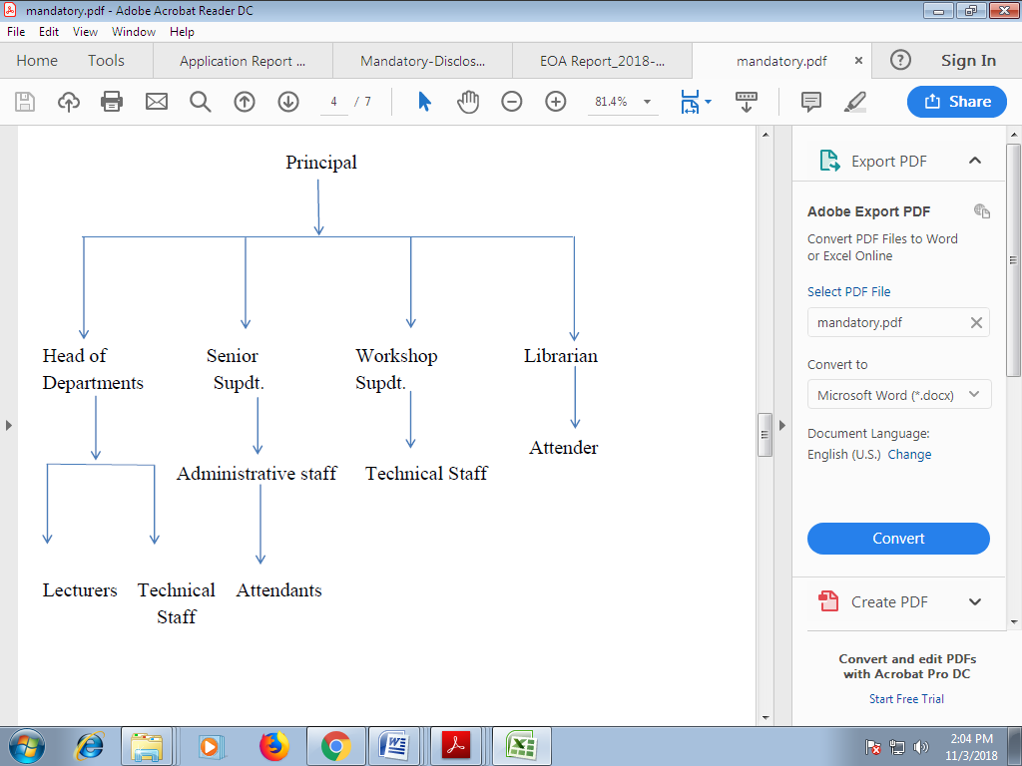

|  |  |  |  |
| --- | --- | --- | --- |
| 10 | Student feedback mechanism on Institutional Governance/faculty performance |  | Yes. There is an in house mechanism to give feedback about the institutional governance and faculty performance |
|  |  |  |  |
|  |  |  |  |
| 11 | Grievance redressal mechanism for faculty, staff and students |  | Yes, Various Committes pescribed by AICTE/ Govt/Dept are formed for Grivance redressal for students,faculty andstaff. |

**12.Department of Electronics Engineering**

|  |  |  |  |  |
| --- | --- | --- | --- | --- |
| Course | | Diploma in Electronics Engineering | | |
| Level | | Diploma | | |
| First Year of Approval by the Council | | | | |
| Year-wise sanctioned Intake | 60+3 (2018) | | 60+3(2019) | 60+3+6(2020) |
| Year-wise Actual admissions | 63 | | 63 | 69 |
| % Students Passed with Distinction | 23.07% | | 7.5% | 14% |
| % Students Passed with First Class | 19.23% | | 17% | 32% |
| Students Placed | 9.5% | | 57.4% | 9% |
| Average Pay Package,Rs./Year | Rs 9,5000/- | | Rs 1,00,000/- | Rs 1,20,000/- |
| Students Opted for Higher Studies | 12.69% | | 15% | 10% |
| Accreditation Status of the Course | | | Not Accredited | |

**Department of Computer Engineering**

|  |  |  |  |  |
| --- | --- | --- | --- | --- |
| Course | | Diploma in Computer Engineering | | |
| Level | | Diploma | | |
| First Year of Approval by the Council | | | | |
| Year-wise sanctioned Intake | 60+3 (2018) | | 60+3(2019) | 60+3+6(2020) |
| Year-wise Actual admissions | 63 | | 63 | 69 |
| % Students Passed with Distinction | 23.07% | | 7.5% | 18% |
| % Students Passed with First Class | 19.23% | | 17% | 28.00% |
| Students Placed | 9.5% | | 57.4% | 20.0% |
| Average Pay Package,Rs./Year | Rs 9,5000/- | | Rs 1,00,000/- | Rs 2,00,000/- |
| Students Opted for Higher Studies | 12.69% | | 15% | 6% |
| Accreditation Status of the Course | | | Not Accredited | |

**Department of Electrical and Electronics Engineering**

|  |  |  |  |  |
| --- | --- | --- | --- | --- |
| Course | | Diploma in Electrical and Electronics Engineering | | |
| Level | | Diploma | | |
| First Year of Approval by the Council | | | | |
| Year-wise sanctioned Intake | 60+3 (2018) | | 60+3(2019) | 60+3+6(2020) |
| Year-wise Actual admissions | 63 | | 63 | 69 |
| % Students Passed with Distinction | 8.5 | | 5.45 | 16.6% |
| % Students Passed with First Class | 17.02 | | 23.63 | 25% |
| Students Placed | 4.7% | | 6% | 2% |
| Average Pay Package,Rs./Year | Rs 1,20,000/- | | Rs 1,20,000/- | Rs 96000/- |
| Students Opted for Higher Studies | 4.7% | | 6% | 4.1% |
| Accreditation Status of the Course | | | Not Accredited | |

|  |  |  |  |  |
| --- | --- | --- | --- | --- |
| **13.Teaching Staff Details** | | | | |
| **Sl No** | **Name of teaching Staff** | **Designation** | **Department** | **Qualification** |
| 1 | Shajan Jacob | Head of Department | Electronics | M-tech |
| 2 | Mohanan Nair C | Lecturer | Electronics | B-tech |
| 3 | Shanifa E | Lecturer | Electronics | B-tech |
| 4 | Jolly B | Lecturer | Electronics | M-tech |
| 5 | Vishnu Devan M T | Guest Lecturer | Electronics | B-tech |
| 6 | Aiswaraya S Pillai | Guest Lecturer | Electronics | M-tech |
| 7 | Saju Sankar S | Head of Department | Computer | M-tech |
| 8 | Sreevidya V S | Lecturer | Computer | M-tech |
| 9 | Vani M | Lecturer | Computer | B-tech |
| 10 | Aswathy S | Guest Lecturer | Computer | M-tech |
| 11 | Lubi E | Guest Lecturer | Computer | M-tech |
| 12 | Priyanga Prasad | Guest Lecturer | Computer | M-tech |
| 13 | Prince A Basheer | Head of Department | Electrical &Electronics | M-tech |
| 14 | Chithra S R | Lecturer | Electrical &Electronics | M-tech |
| 15 | Remya L G | Lecturer | Electrical &Electronics | M-tech |
| 16 | Leena K Y | Guest Lecturer | Electrical &Electronics | M-tech |
| 17 | Bob Mathew Syji | Guest Lecturer | Electrical &Electronics | M-tech |
| 18 | Raeesamole A | Guest Lecturer | Electrical &Electronics | M-tech |
| 19 | Arun P Raj | Lecturer | Mechanical |  |
| 20 | Dr.Prasida P | Assistant Professor (English) | General | MA, phD |
| 21 | Ignatius J | Assistant Professor  (Physics) | General | Msc, phD |
| 22 | Laiji R | Assistant Professor(Guest)  (Chemistry) | General | Msc,MEd |
| 23 | Nisha B S | Assistant Professor(Guest)  (Mathematics) | General | Msc,Mphil,MEd |

|  |  |  |  |
| --- | --- | --- | --- |
| 14 | Admission Entrance test / admission criteria |  | Department of Technical Education, Kerala conducts admission to various polytechnic colleges in the state through a Single Window Admission System. For prospectus and other details |
|  |  |  | visit http://www.polyadmission.org |
|  |  |  |  |
|  | Fees in rupees |  | Admission Fee : 200 (At the time of Admission) |
|  |  |  | Tuition Fee : 750 (Every Semester) |
|  |  |  | Special Fee : 700 (Every Year, at the beginnig of odd sem). |
|  |  |  | P.D : 600 (Every Year, at the beginnig of odd sem). |
|  |  |  | Students Amenities Fee: 350 (Every Year, at the beginnig |
|  |  |  | of odd sem). |
|  |  |  | Caution Deposit : 500 (At the time of Admission) |
|  |  |  |  |
|  | Number of Fee Waivers offered |  | 6(2014) 6(2013) 6(2012) |
|  | Admission Calendar |  | April to June Every Year |
|  | PIO quota |  | No |
| 15 | Infrastructural information^ |  |  |
|  | Classroom/Tutorial Room facilities |  | 13 |
|  | Laboratory details |  | 14 |
|  | Computer Centre facilities |  | Yes, Common Computing Facility |
|  | Library facilities |  | No of Titles : 8600 |
|  |  |  |  |
|  |  |  | No of Volumes :2200 |
|  |  |  | No of National Journals: 15 |
|  |  |  | Computerised with Koha Library Management Software |
|  |  |  |  |
|  | Auditorium / Seminar Halls / Amphi |  | Yes |
|  | Cafeteria |  | Yes |
|  | Indoor Sports facilities |  | No |
|  | Outdoor Sports facilities |  | Yes |
|  | Gymnasium facilities |  | Yes |
|  | Facilities for disabled |  | Yes |
| 16 | Boys Hostel |  | No |
|  | Girls Hostel |  | Yes |
|  | Medical & other Facilities at Hostel |  | Yes |
| 17 | Academic Sessions |  | June - September (Odd Semester) |
|  |  |  | October - November (Examination - Odd Semester) |
|  |  |  | December - March (Even Semester) |
|  |  |  | April - May (Examination - Even Semester) |
|  | Examination system, Year / Sem |  | Semester System |
|  | Period of declaration of results |  | December (Even Semester) |
|  |  |  | June (Odd Semester) |
| 18 | Counseling / Mentoring |  | Yes |
|  | Career Counseling |  | Yes |
|  | Medical facilities |  | Yes |
|  | Student Insurance |  | Yes |
| 19 | Students Activity Body |  | College Union |
|  | Cultural activities |  | College Arts Festival, Inter Polytechnic Arts |
|  |  |  | Festival etc |
|  | Sports activities |  | College and Inter Polytechnic Games and Athletics Meet |
|  | Facilities |  | Community Development through Polytechnic |
|  |  |  | • National Service Scheme (NSS) |
|  |  |  | • Innovation and Entrepreneurship Development Club (IEDC) |
|  |  |  | • Continuing Education Cell (CEC) |
|  |  |  | • Finishing School |
|  |  |  | • Visiting Faculty Scheme |
|  |  |  | • Scholar Support Programme  . Entrepreneurship Development Club (ED Club) |
|  |  |  |  |
|  | Magazine / Newsletter |  | College Magazine will be published every year |
|  | Technical activities / TechFest |  | Yes |
|  |  |  |  |
|  | Industrial Visits / Tours |  | Yes |
|  | Alumni activities |  | Yes |
| 20 | Name of the Information Officer for |  | Emilia Morris |
|  | RTI |  | (Appellate Authority) |
|  | Designation |  | Principal |
|  | Phone number with STD code |  | 0475-2228683 |
|  |  |  |  |
|  | FAX number with STD code |  | 0475-2228683 |
|  | Email |  | [gptcplr@gmail.com](mailto:gptcplr@gmail.com) |
|  |  |  |  |
|  | Name of the Information Officer for |  | B Radhakrishnan Nair |
|  | RTI |  | (Public information Officer) |
|  | Designation |  | Senior Superintendent |
|  |  |  |  |
|  | Phone number with STD code |  | 0475-2228683 |
|  |  |  |  |
|  | FAX number with STD code |  | 0475-2228683 |
|  | Email |  | [gptcplr@gmail.com](mailto:gptcplr@gmail.com) |
|  |  |  |  |
|  | Name of the Information Officer for |  | Beena A |
|  | RTI |  | (Assistant information Officer) |
|  | Designation |  | Head Clerk |
|  |  |  |  |
|  | Phone number with STD code |  | 0475-2228683 |
|  |  |  |  |
|  | FAX number with STD code |  | 0475-2228683 |
|  | Email |  | [gptcplr@gmail.com](mailto:gptcplr@gmail.com) |
|  |  |  |  |